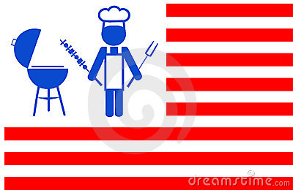
THURSDAY
JUNE 9TH
11:30-2:00
(Lunch served at 12:00)

TREX Decking & RAIL, Certainteed Trim & Roofing, Rockwool, Ben Moore, Simpson Strong Tie, ABC Metal Roofing National Vinyl Windows Jeld-wen Doors Westbury Rail And More!

There will be raffles and giveaways!!

Have some lunch catered by our friends at Meyers Catering AKA RIFFS JOINT!
Delicious food, great company!!
Awesome products!
Come join the FUN!

